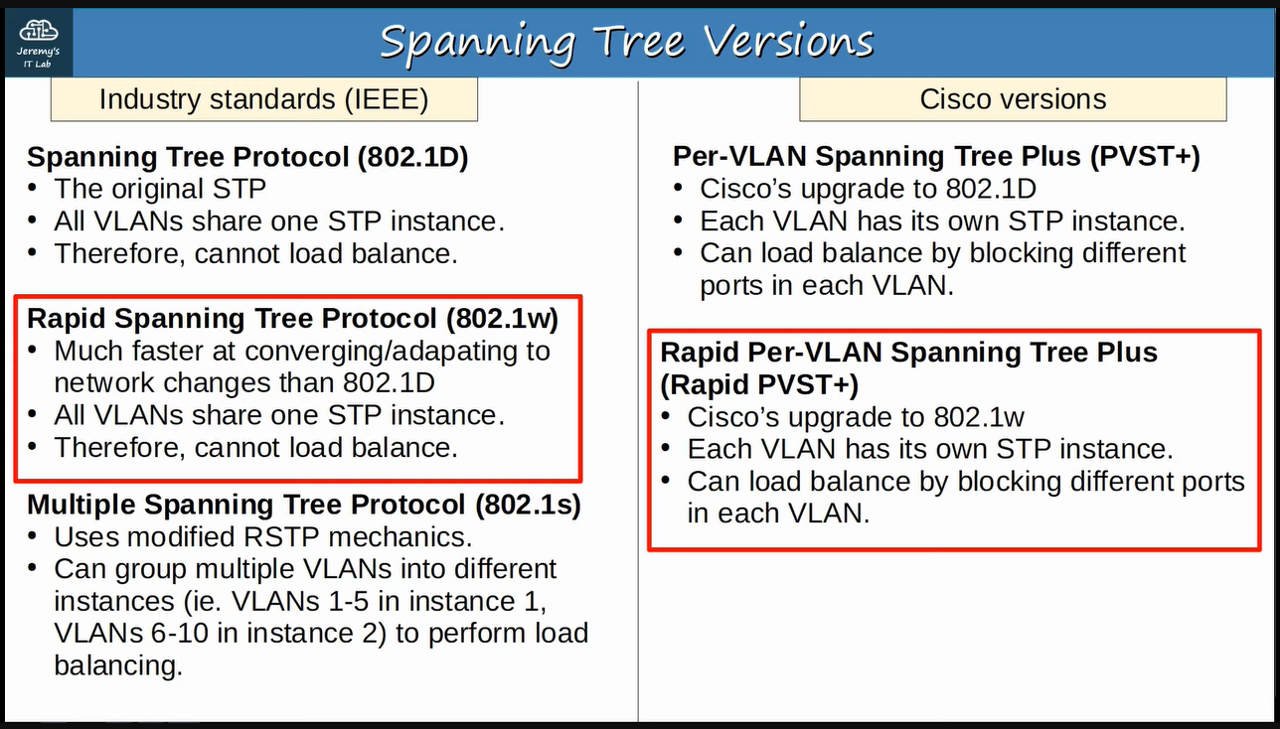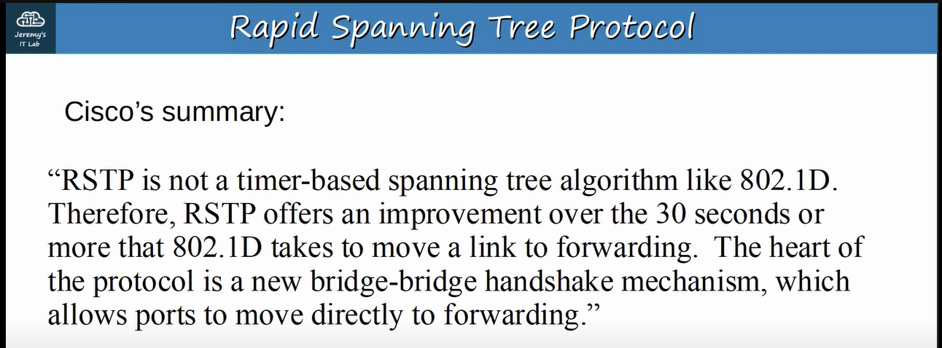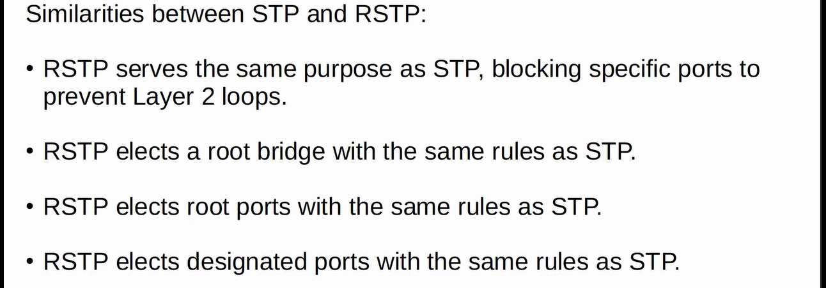

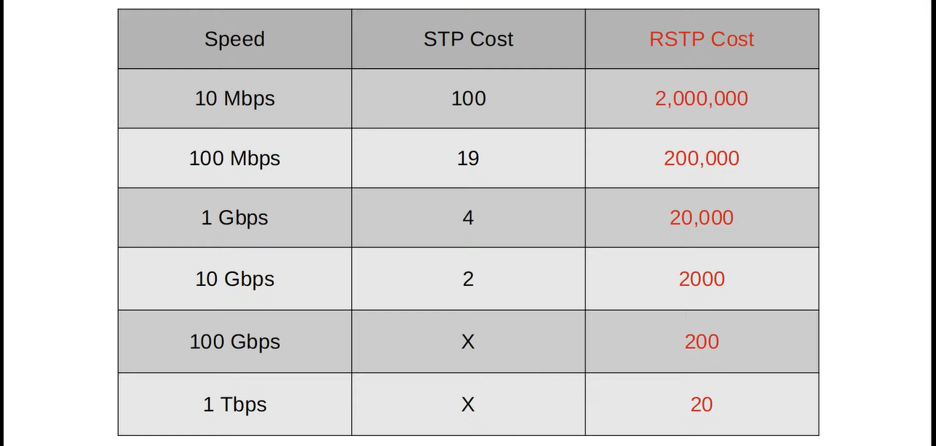

**In RSTP, the listening state is gone and the blocking & the disabled states have become the “discarding”. ↓**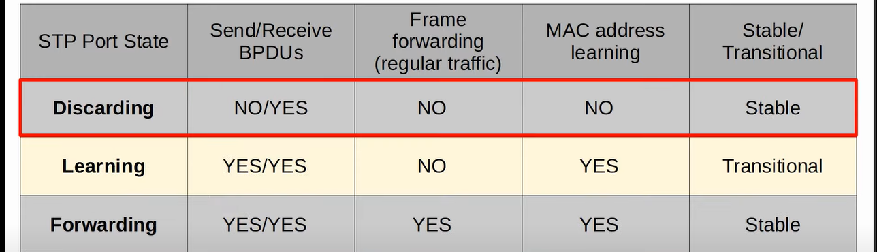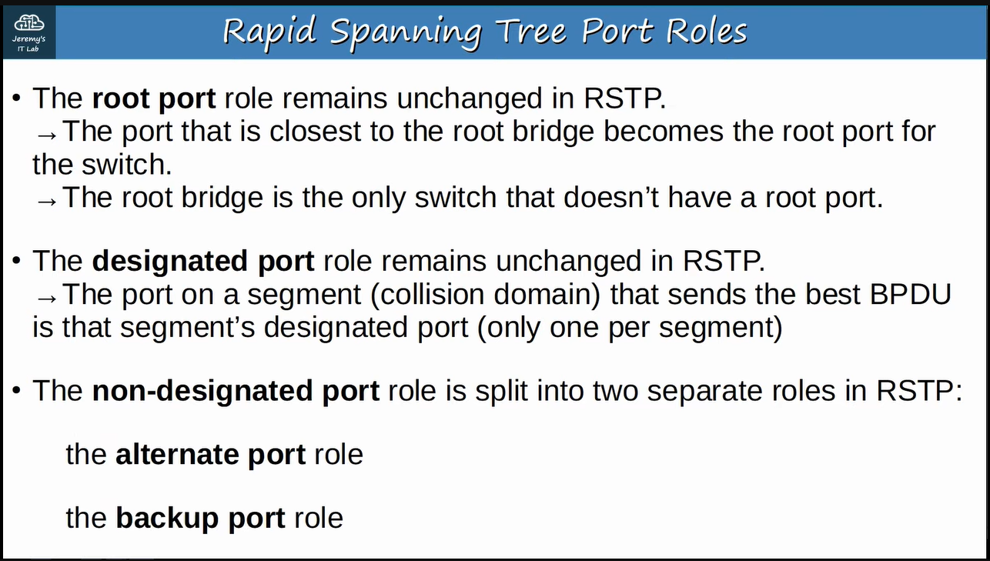

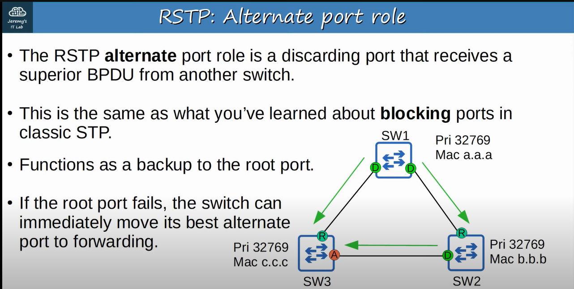 **↓**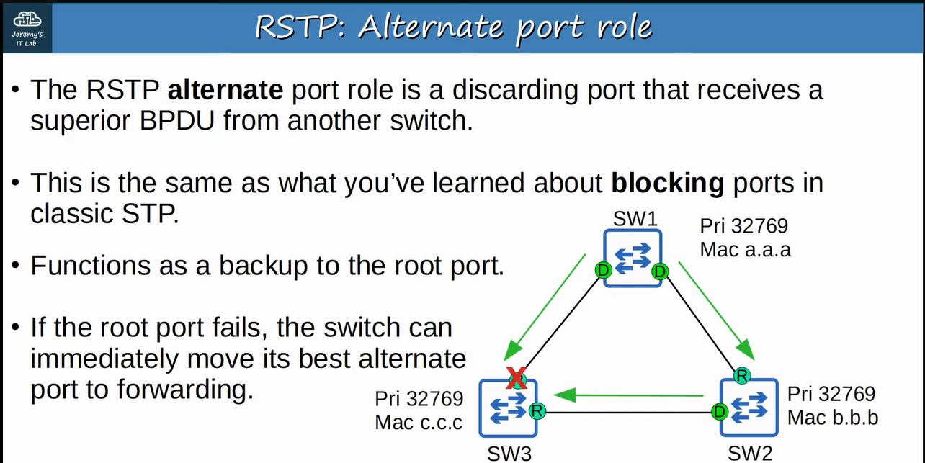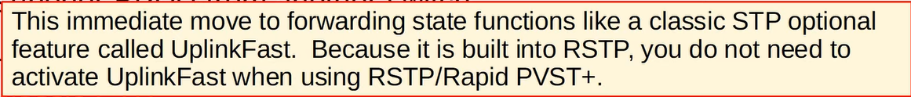

**“BackboneFast” is also an optional feature of RSTP. Let’s understand with an example. Suppose the connection between SW1 and SW2 has been lost and SW1 is a root bridge then SW2 will not receive the BPDUs from SW1 and it will send its own BPDUs the SW3 then without this functionality, SW3 will just ignores these BPDUs from SW2 until its non-designated port, in classic STP, finally changes to a designated port and forwards SW1’s BPDUs to the SW2 and then SW2 will accept the SW1 as its root bridge again, but with this functionality, the max-age timer on that interface of SW3 will be expired and it will rapidly send SW1’s BPDUs to SW2 ↓** 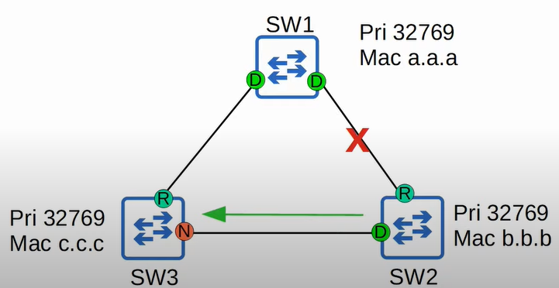

**↓**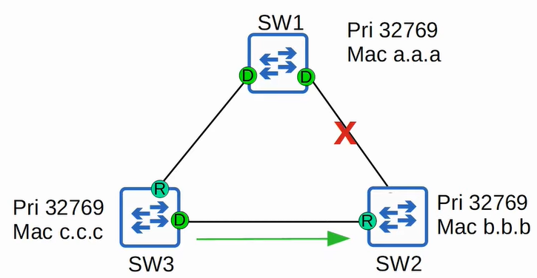

**“Backup Port” works when the designated port stops working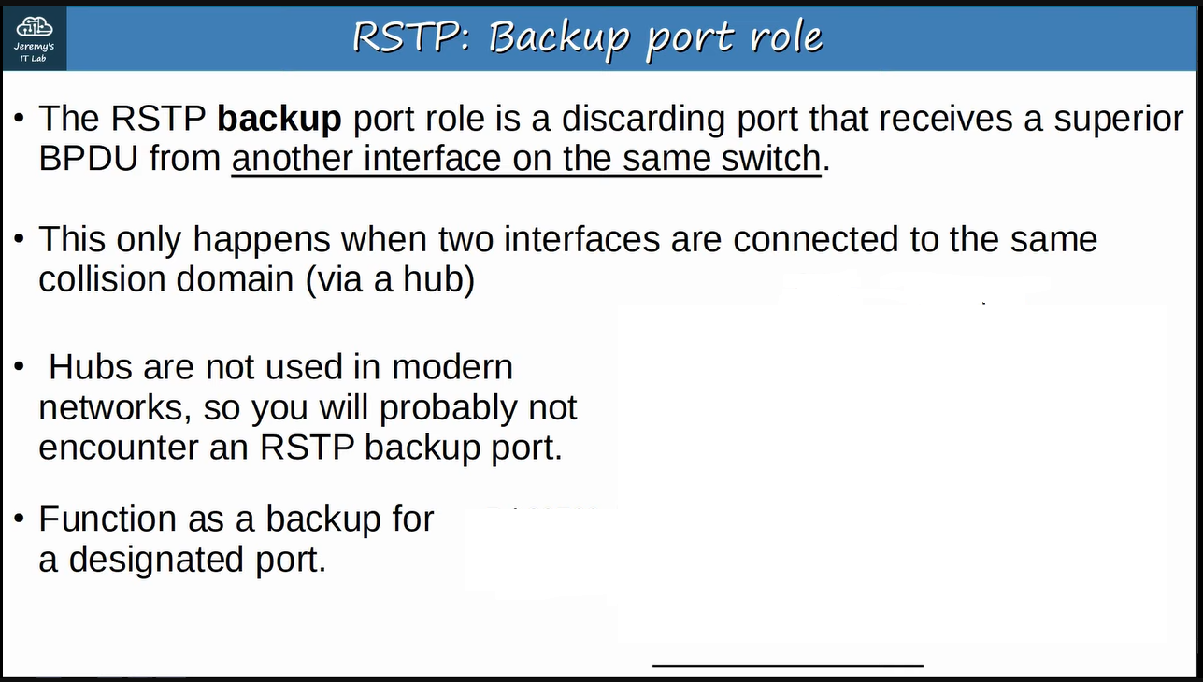E.g., ↓**

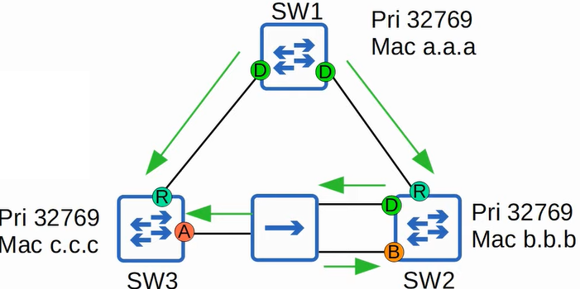

**↓**

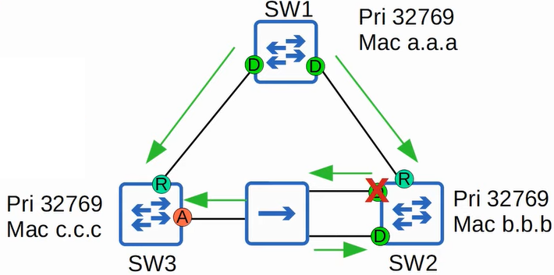

**Remember ↓**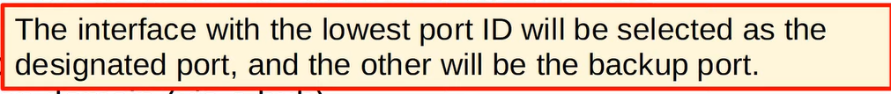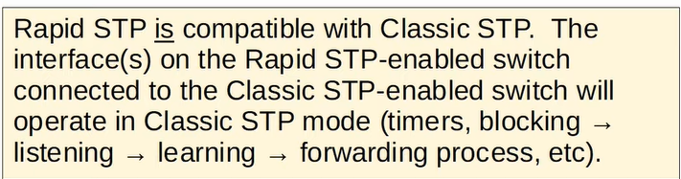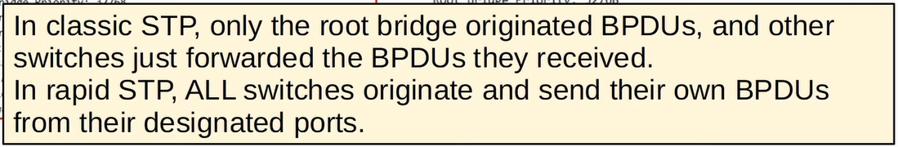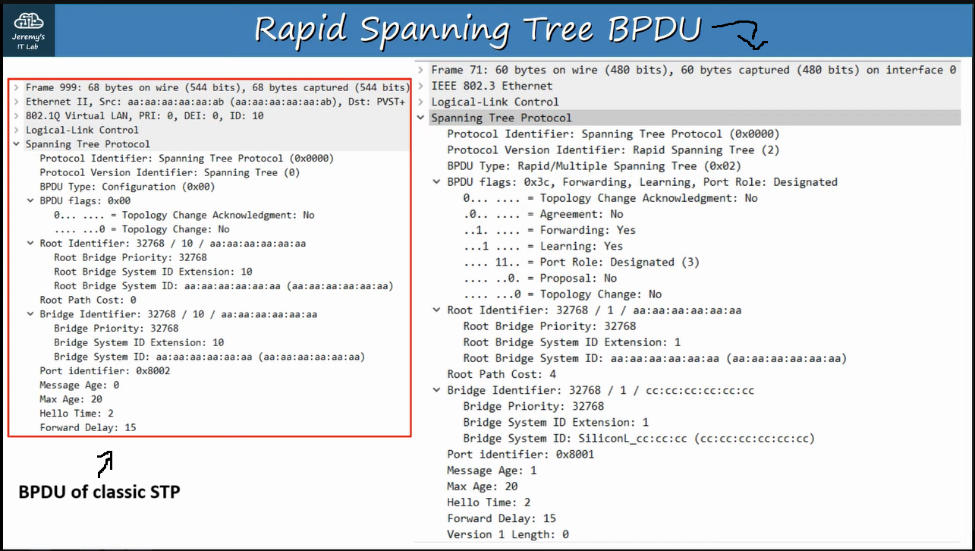

**Some difference between TSP & RSTP ↓**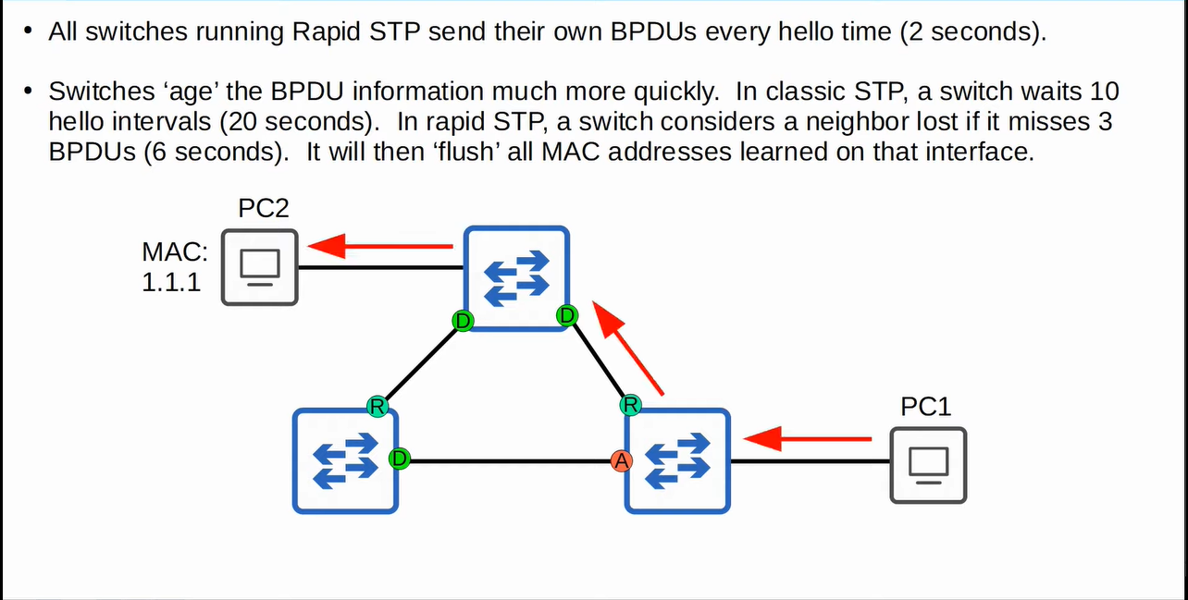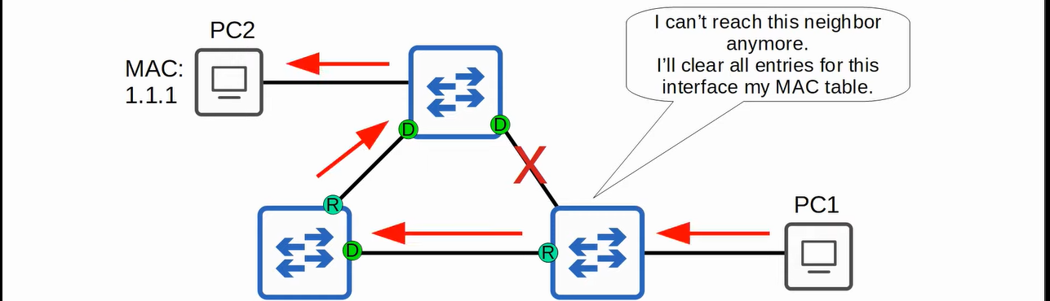

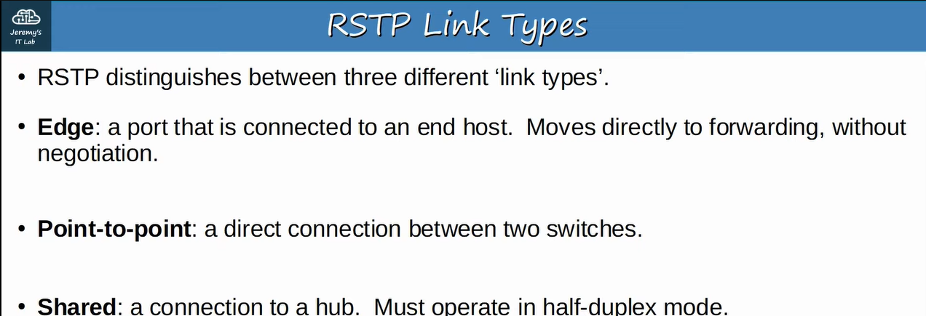

**↓**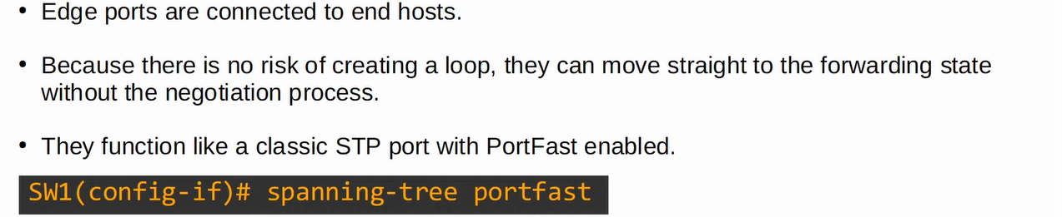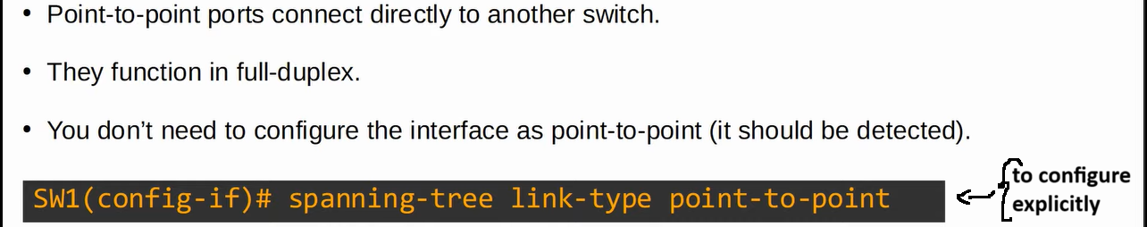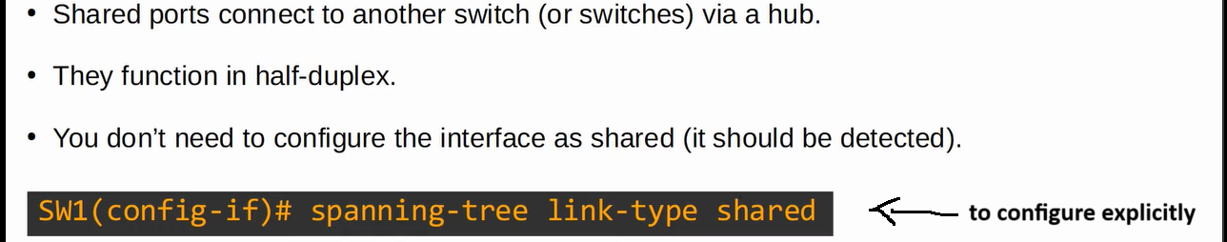

**e.g., ↓**

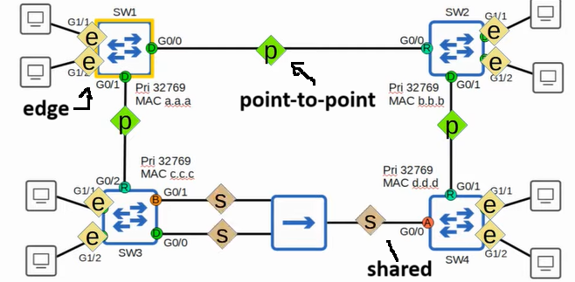



**Example ↓**